## Formal Logic III

Background

This is a continuation of Formal Logic II. The aims are:

propositional logic – declarative sentences, natural deduction, semantics, normal forms

predicate logic – syntax, natural deduction, semantics, undecidability

modal logics – syntax, semantics, logic engineering, natural deduction, multi-agent systems

**Lesson 0**

Propositional logic  
 : Susan saves

: Susan buys a house

: The house has seven bathrooms

: The house is used as a guesthouse

: Peter likes the house

**“only if”**

“The house is used as a guesthouse sonly if it has seven bathrooms”

“Susan buys a house only if the house does not have seven bathrooms”

**“unless”**

“if… then”

“Unless Susan saves, she does not buy a house with seven bathrooms”

“Unless Peter does not like the house, Susan saves and buys a house used as guesthouse”

*Negate one side of the statement*

**“if and only if”**

“logically equivalent to”

“The house is used as a guesthouse if and only if Susan does not buy it, but Peter likes it”

“Peter likes the house if and only it has seven bathrooms or is not used as guesthouse”

*Remember “but” in logic is treated as “AND”*

**Lesson 0**

Symbols

|  |  |  |
| --- | --- | --- |
| **Symbol** | **Name** | **Description** |
|  | phi | Premise/formula |
|  | psi | Conclusion |
|  | Proves | Proves/implies/yields. (Syntactically entails) |
|  | Sequent | Is valid if a proof can be found |
|  |  |  |

We apply proof rules to premises, we get formulas.

We apply more proof rules to formulas, we get a conclusion

Hence:

Example:

**Lesson 1**

Natural Deduction Rules

Natural deduction is used to examine the validity of arguments. It can sometimes be more efficient than a truth table. This is like Fitch Rules, where the goal is to build a proof, using some type of ruleset.

Recap:

Elim: Eliminate or remove parts

Intro: Introduce or add parts

Example

*Prove that implies*

1 assume a & b.

2 b. &E2 1

3 a. &E1 1

4 b & a. &I 2,3

5 therefore a & b => b & a. =>I 1,4

Conjunction ()

: I am happy

: The sun is shining

|  |  |  |  |
| --- | --- | --- | --- |
|  |  | Sentences to cite | Usage |
|  | **And_Intro.**  Replaces the current goal by the two goals A and B  *I am happy, and the sun is shining*  *is true. is true. Implies is true* | Any. May cite as many prior lines as you like, and each will be a conjunct. | Introduce a new conjunction on any line of a proof by citing each of the conjuncts from prior lines.  These conjuncts must be alone on the line cited. |
|  | **And_Elim_1 in H.**  Applies to an assumption of the form H:  And generates a new assumption HO:  *I am happy*  *is true. Implies is true* | (*Elim): for each conjunct, the assumption.*  *Enter every conjunct from the assumption. On a new line* | Remove a conjunct from a previous line containing a conjunction. |
|  | **And_Elim_2 in H.**  Applies to an assumption of the form H:  And generates a new assumption HO:  *The sun is shining*  *is true. Implies is true* | (*Elim): for each conjunct, the assumption.*  *Enter every conjunct from the assumption. On a new line* | Remove a conjunct from a previous line containing a conjunction. |
|  | **And_Elim_all in H.**  Applies to an assumption of the form H:  And generates two assumptions  H:  HO:  The tactic is then recursively applied to H and HO |  |  |

*Intro: Cite as many sentences as you like*

*All must be conjuncts*

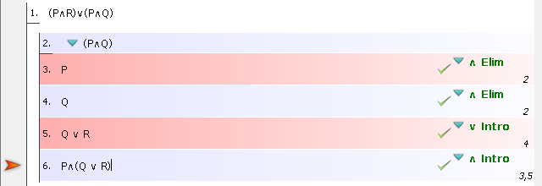

*Elim: for each conjunct, cite 2.*

*Enter every conjunct from 2. On a new line*

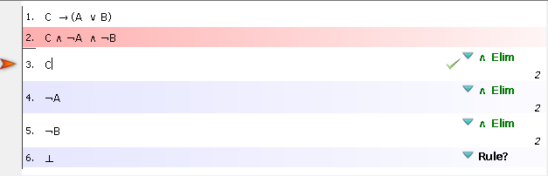

Disjunction ()

: I am happy

: The sun is shining

|  |  |  |  |
| --- | --- | --- | --- |
|  |  | Sentences to cite | Usage |
|  | **Or_Intro_1**  Replaces the current goal by the goal | Any. Cite only one prior line, it will be a disjunct. | You can cite any prior sentence available and create a disjunction containing as one conjunct the prior line cited and as another disjunct any sentence you like. |
|  | **Or_Intro_2.**  Replaces the current goal by the goal | Any. Cite only one prior line, it will be a disjunct. | You can cite any prior sentence available and create a disjunction containing as one conjunct the prior line cited and as another disjunct any sentence you like. |
|  | **Or_Elim in H.**  Applies to an assumption of the form H:  It generates two proof obligations with the assumptions  H: resp.  H: and the current goal | *(∨ Elim) Cite Assumption. And each subproof* | *Each disjunct should be subproof*  *Each subproof should have the same goal as the other*  *The goals in the subproofs should match a new goal outside* |

*(∨ Intro). Cite only one prior line, it will be a disjunct.*

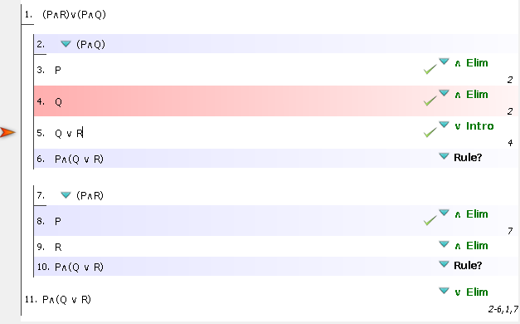

*(∨ Elim) Cite 1. And each subproof*

*Each disjunct should be subproof*

*Each subproof should have the same goal as the other (in this case,)*

*The goals in the subproofs should match a new goal outside (in this case, our intermediate conclusion ,))*

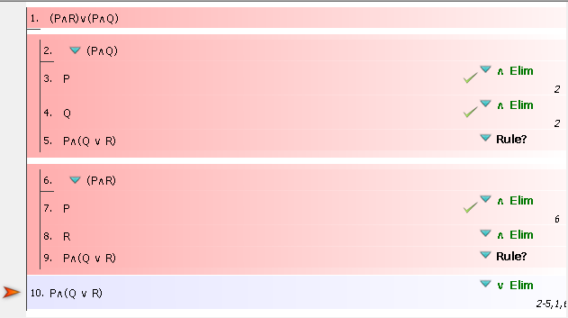

Implication ()

: I am happy

: The sun is shining

|  |  |  |  |
| --- | --- | --- | --- |
|  |  | Sentences to cite | Usage |
|  | **Impl_Intro.**  Replaces the current goal by and adds the assumption H: | You must cite only a single subproof. | To prove a conditional statement, make a subproof that begins with the antecedent and ends with the consequent. |
|  | **Impl_Elim in H and HO.**  Applies to the two assumptions of the form H: and HO: and adds the new assumption H1: | You must cite exactly two sentences:   1. a conditional and 2. a sentence that is the antecedent of the conditional in 1. | You can only prove the consequent of the conditional cited in 1. above. |

*-> Intro:*

*Add a new subproof*

*The assumption of the subproof should be the antecedent ()*

*The conclusion of the subproof should be the consequent ()*

*-> Elim: Cite a conditional (1.)*

*and a sentence that’s an antecedent of the conditional (3.)*

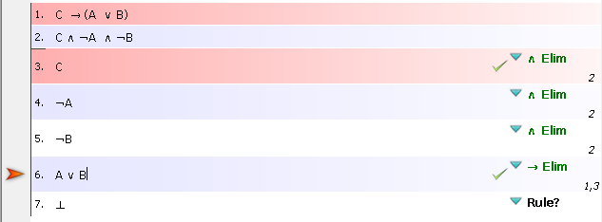

Negation ()

: I am happy

: The sun is shining

|  |  |  |  |
| --- | --- | --- | --- |
|  |  | Sentences to cite | Usage |
|  | **Not_Intro.**  Replaces the current goal by by False and adds the assumption H: | Cite only a single sub proof that begins with the opposite of what you hope to prove and ends with Contra. | Begin a sub proof with the opposite of what you want to prove outside of the sub proof. End the sub proof with Contra.  Cite only the sub proof. |
|  | **Impl_Elim in H and HO.**  Applies to the two assumptions of the form H: and HO: and adds the new assumption H1: False | Cite only a negation of a negation. | If there is a sentence with at least two negations on it, you can take the negations off, two at a time, with this rule.  Cite only one sentence. |

*(¬ Intro) Cite only a single subproof that begins with the opposite of what you hope to prove and ends with Contra*

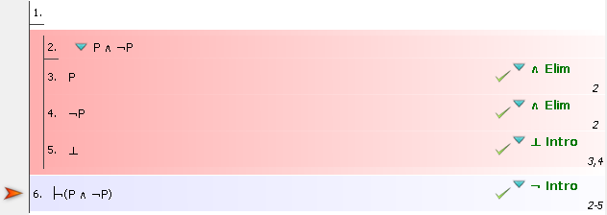

|  |  |  |  |
| --- | --- | --- | --- |
|  | **PBC**  *Proof by contradiction (Contradiction Introduction)*  Replaces the current goal by False and adds the assumption H: A. | *(⊥ intro)*   * A sentence and, * Exactly that sentence, negated. Cite only two sentences. | Find a sentence and its negation. Cite both and write Contra on a line. |

*(⊥ intro) Cite 4. and 7.*

*(⊥ intro) Cite 5. and 9.*

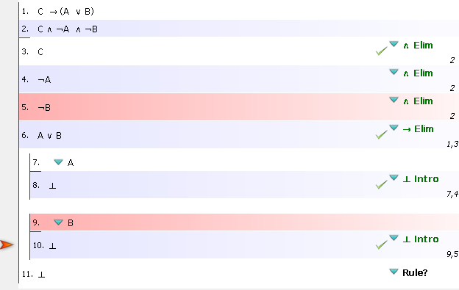

Universal ()

: I am happy

: The sun is shining

|  |  |  |  |
| --- | --- | --- | --- |
|  | **Forall_Intro.**  Replaces the current goal forall by and adds the variable : to the assumptions. |  |  |
|  | **Forall_Elim in H with t.**  Applies to an assumption of the form H : forall . It generates a new assumption HO: . |  |  |

*∀ Elim: Cite 1.*

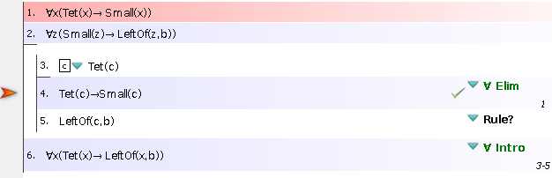

Existential ()

: I am happy

: The sun is shining

|  |  |  |  |
| --- | --- | --- | --- |
|  | **Exists_Intro with t.**  Replaces the current goal exist by |  |  |
|  | **Exists_Elim in H.**  Applies to an assumption of the form H : exists . It adss the variable : and the new assumption HO: |  |  |

Proofs practice (ASS1)

**ASS1: Q7**

*(∨ Elim) Cite 1. And each subproof*

*Each disjunct should be subproof*

*Each subproof should have the same goal as the other (in this case,)*

*The goals in the subproofs should match a new goal outside (in this case, our intermediate conclusion, )*

*Elim: for each conjunct, cite the assumption.*

*Enter every conjunct from the assumption. On a new line*

*Intro: Cite as many sentences as you like*

*All must be conjuncts*

*(∨ Intro). Cite only one prior line, it will be a disjunct.*

**ASS1: Q8**

*-> Intro:*

*Add a new subproof*

*The assumption of the subproof should be the antecedent ()*

*The conclusion of the subproof should be the consequent ()*

Use . You already have in subproof. Try get into subproof

*-> Elim: Cite a conditional (1.)*

*and a sentence that’s an antecedent of the conditional (4.)*

*Intro: Cite as many sentences as you like*

*All must be conjuncts*

**ASS1: Q9**

*-> Intro:*

*Add a new subproof*

*The assumption of the subproof should be the antecedent ()*

*The conclusion of the subproof should be the consequent ()*

*(∨ Elim) Cite 1. And each subproof*

*Each disjunct should be subproof*

*Each subproof should have the same goal as the other (in this case)*

*The goals in the subproofs should match a new goal outside*

Use . You already have in subproof. Try get into subproof

Use . You already have in subproof. Try get into subproof

*-> Elim: Cite a conditional*

*and a sentence that’s an antecedent of the conditional*

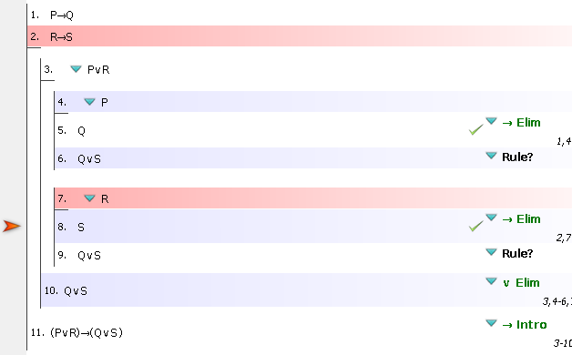

*(∨ Intro). Cite only one prior line, it will be a disjunct.*

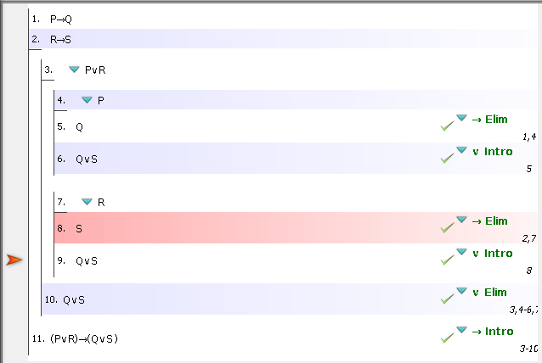

**ASS1: Q11**

